✅ **Query 1: Show all customers and their orders (LEFT JOIN)**

* **Overview: Display all customers' orders.**
* **Data Used: customers, orders**
* **Analysis Technique: LEFT JOIN to include customers even without orders**
* **Tools Applied: MySQL, SELECT, LEFT JOIN, ORDER BY**

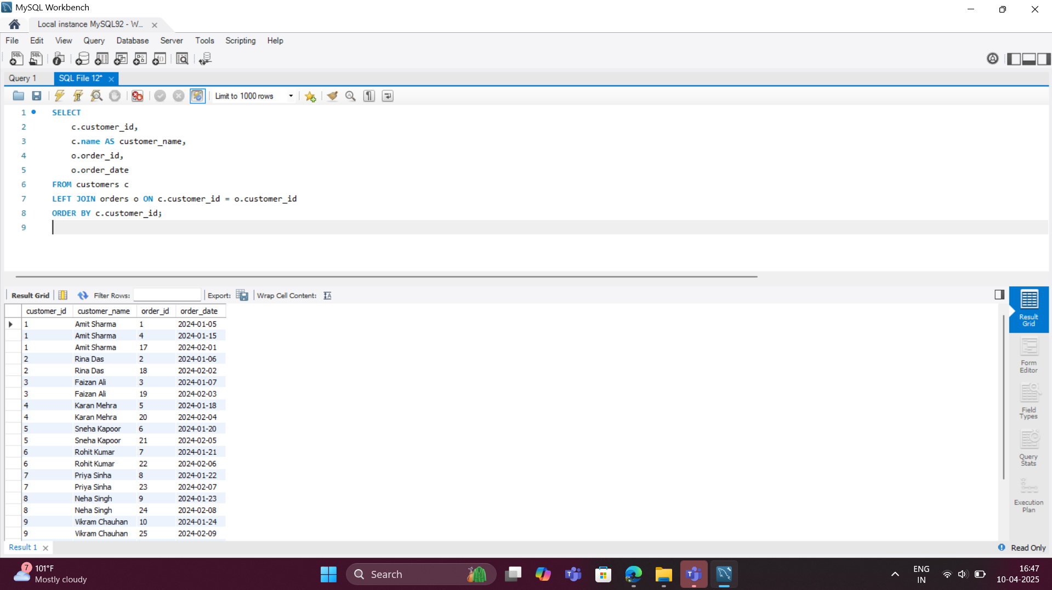

✅ **Query 2: Total orders by each customer**

* **Overview:** Count total orders placed by each customer
* **Data Used:** customers, orders
* **Analysis Technique:** JOIN, COUNT aggregation, GROUP BY
* **Tools Applied:** MySQL, COUNT(), GROUP BY, ORDER BY

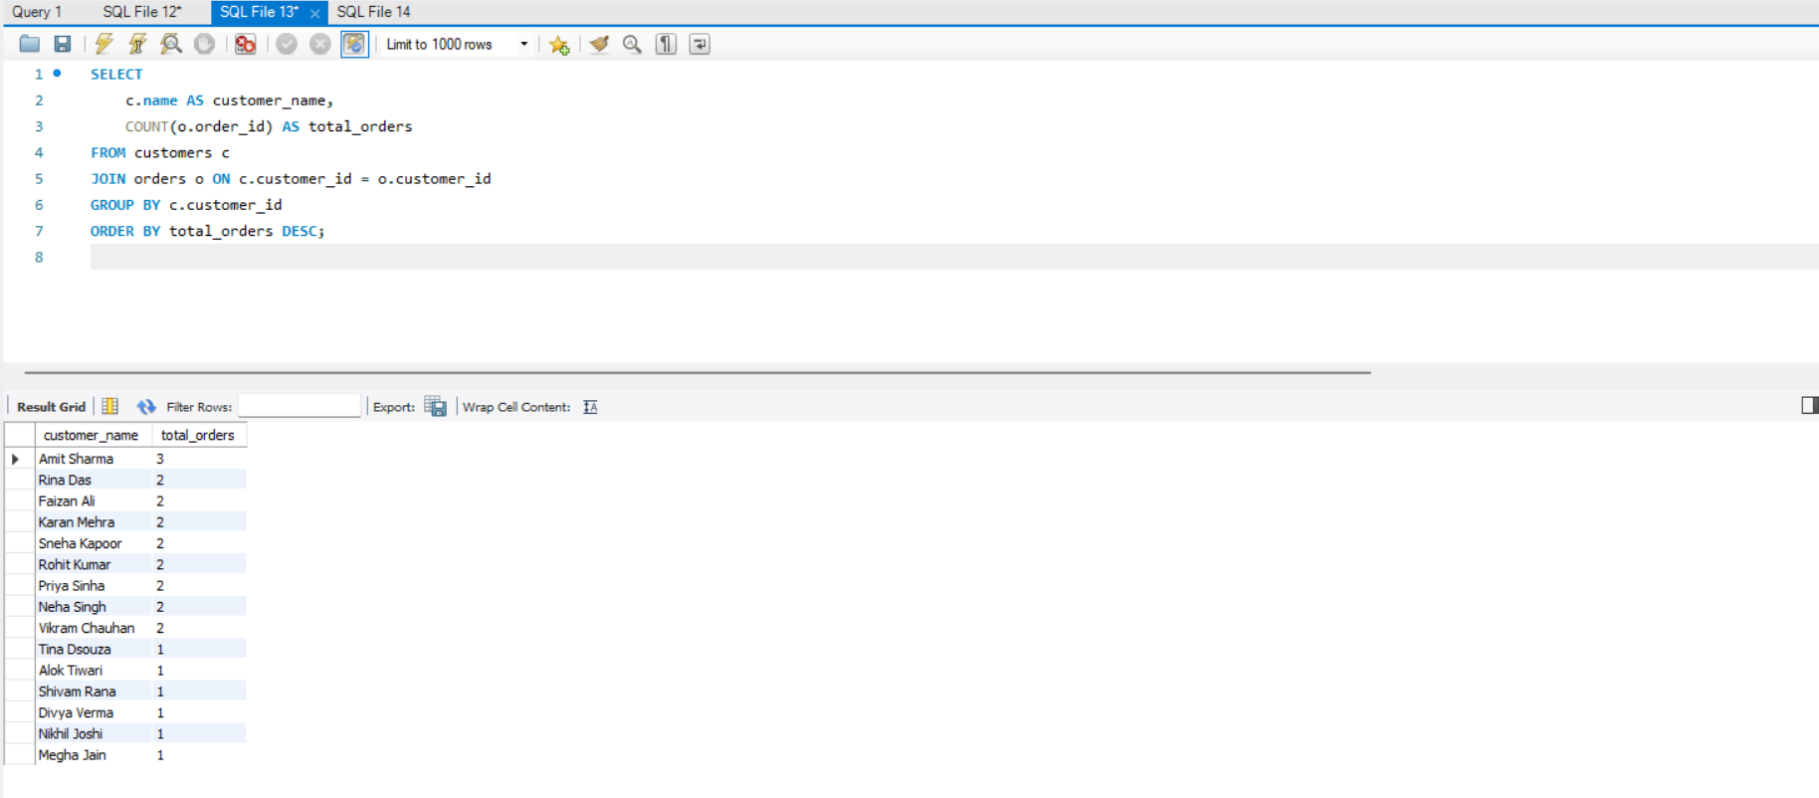

✅ **Query 3: Customers with more than 2 orders**

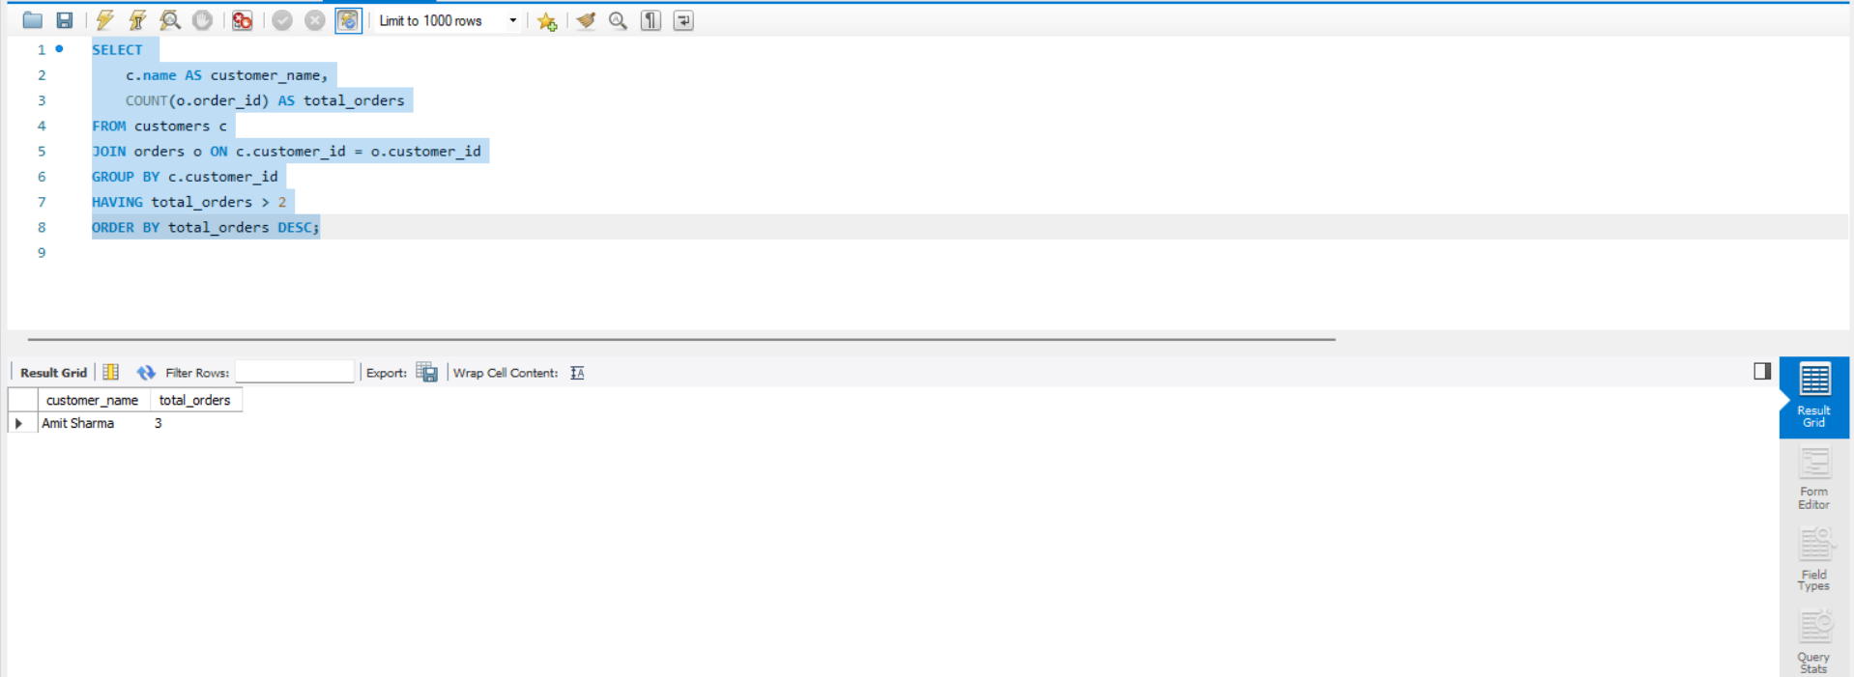

* **Overview:** Identify high-frequency customers with more than 2 orders
* **Data Used:** customers, orders
* **Analysis Technique:** GROUP BY with HAVING filter
* **Tools Applied:** MySQL, COUNT(), GROUP BY, HAVING

✅ **Query 4: Latest order for each customer**

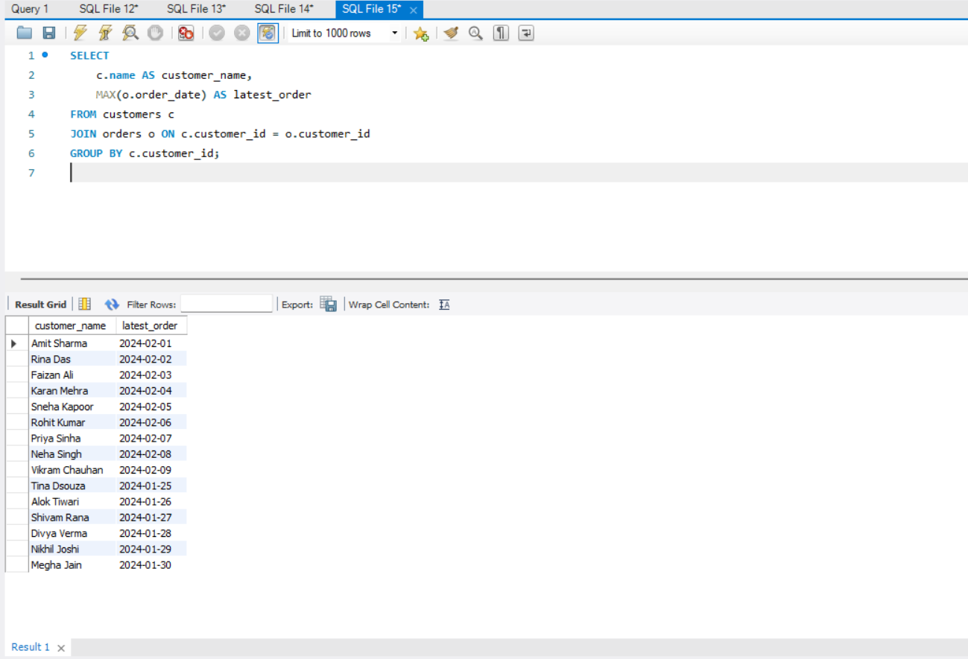

* **Overview:** Find the most recent order date per customer
* **Data Used:** customers, orders
* **Analysis Technique:** Aggregation using MAX()
* **Tools Applied:** MySQL, MAX(), GROUP BY

✅ **Query 5: Total revenue by customer**

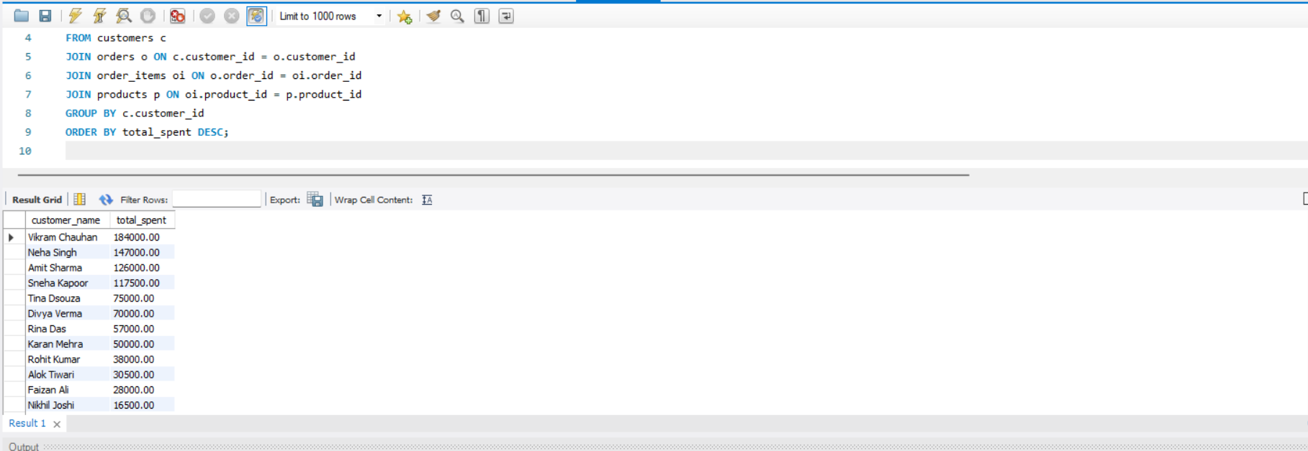

* **Overview:** Calculate how much each customer has spent in total
* **Data Used:** customers, orders, order_items, products
* **Analysis Technique:** Revenue calculation using JOINs and SUM
* **Tools Applied:** MySQL, JOIN, SUM(), Arithmetic, GROUP BY

✅ **Query 6: Top 3 customers by total spending**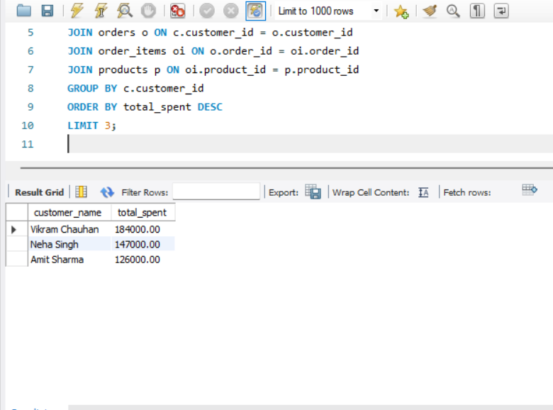

**✅ Query 7: Number of products in each order**

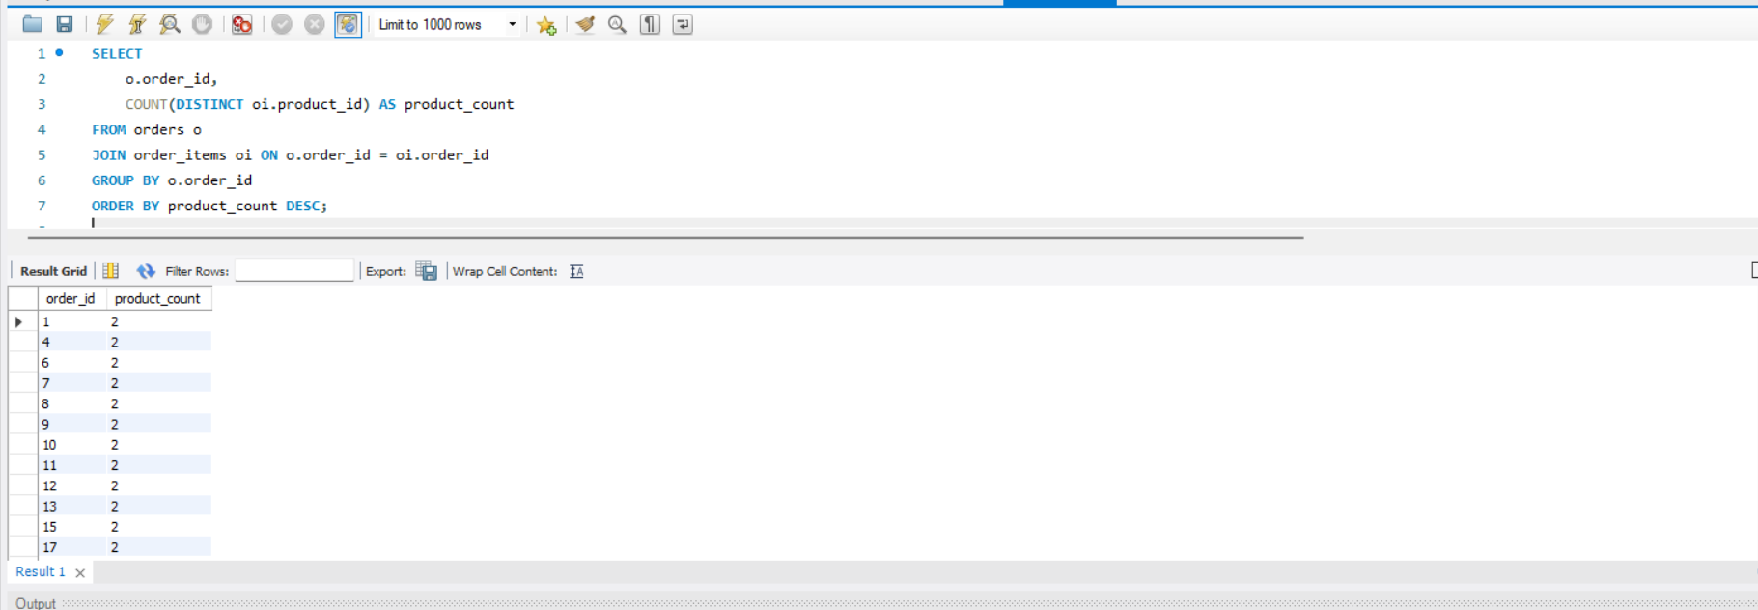

* **Overview:** Count how many distinct products are in each order
* **Data Used:** orders, order_items
* **Analysis Technique:** COUNT DISTINCT with GROUP BY
* **Tools Applied:** MySQL, COUNT(DISTINCT), GROUP BY